CPWIFISW1-TX KIT

Want all the benefits of a WiFi smart switch to control your gate but don’t have a signal there?
The CPWIFISW1-TX KIT is the solution. Simply power up the WiFi switch in your house and wire the receiver into your gate panel. When activated the WiFi switch will transmit to the receiver at a range of up to 100 metres and open the gate.

Features:
- Connects to the home WiFi
- Open gate remotely through the App
- Works with Tuya or Smartlife App
- Manage multiple smart switches and other Tuya compatible smart devices from one App
- Compatible with Amazon Alexa, Google Assistant & Siri (via Shortcuts)
- Set schedules and timers
- Share access with other users permanently or for a set time period
- Remove access to other users instantly
- Up to 100 metre range between WiFi switch and receiver
WiFi Switch specification:
- Power supply: 7-32Vac/dc or 5V Micro-USB
- WiFi standard: 2.4GHz
- Transmission frequency: 868MHz
- Dimensions: 73 x 46 x 30mm
Receiver specification:
- Power supply: 12-24Vac/dc
- Normally open relay output to trigger gate
- Can also learn other Quantek remote controls
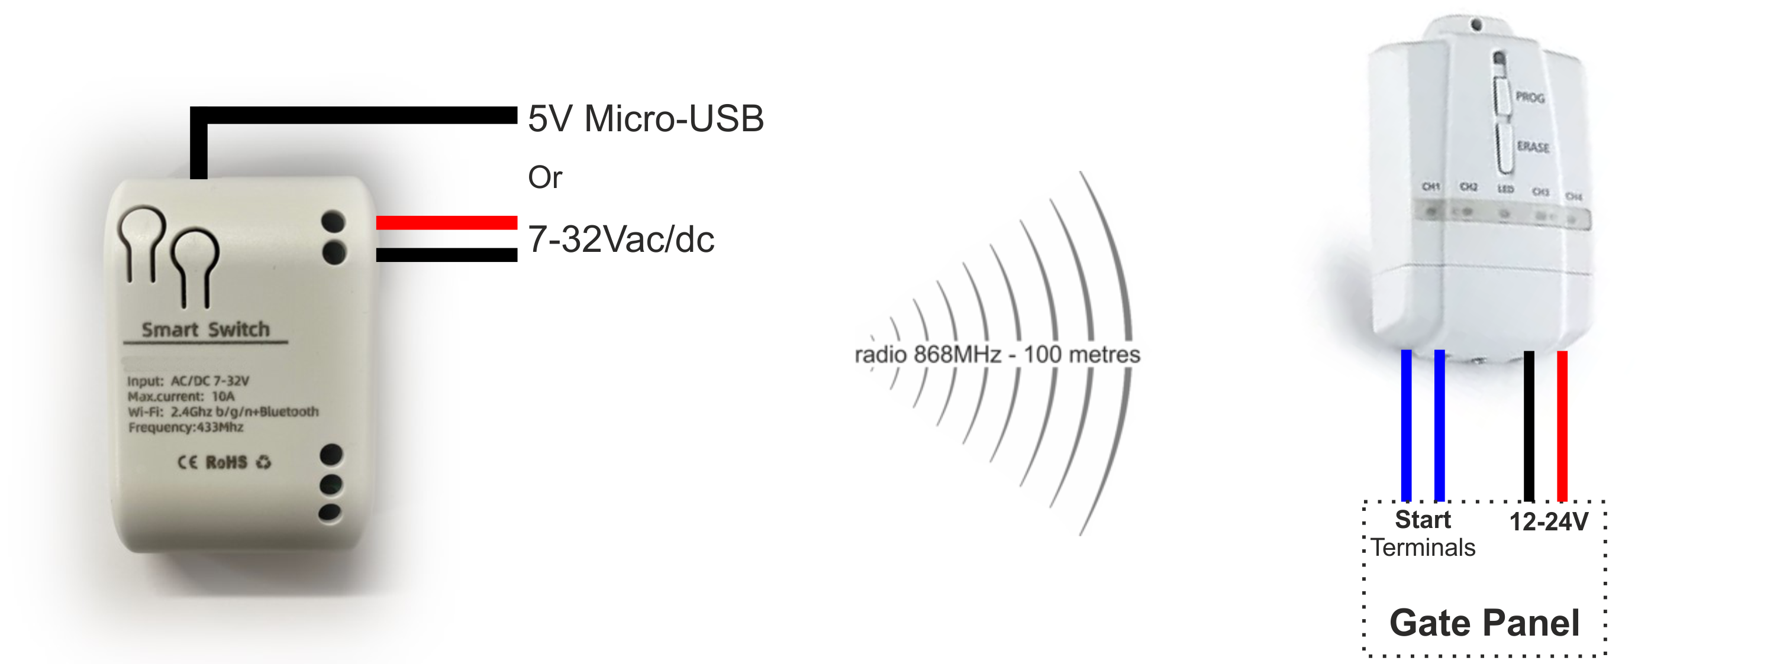
- Dimensions: 89 x 56 x 21mm

